Test final

1. Write the plural forms of the nouns : (2p)
a. watch ……watches………………..
b. mouse ……mice……………….
3. Choose the correct answer: (2p)
A. All the …roofs………….were covered with snow.
a) roofs b) rooves c) roovs
B. Some of the …photos………… are worth framing.
a) photoes b) photos c)photoies

4. Look at the pictures and complete the sentences: (2p)

fox person table tomato
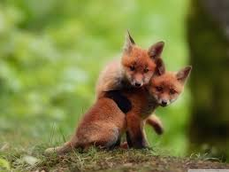

a. There are many……tables………. in the cafeteria.
b. Two little ……foxes………… are playing on the grass.
c. There are six ……people…………. in my family.
d. Mom is slicing two ……tomatoes…………………. .
5. True or false? (2p)
a) The feminine form of lion is lioness. (T / F )
b) A drake can lay eggs. (T / F)
Good luck!

